The University of Azad Jammu and Kashmir, Muzaffarabad

Name: Alishba Zakir
Roll No: 2024-SE-02
Course: DataBase Systems
Course Code: CS-2204
Lab: 03
Submitted To: Engr. Awais Rathore
Submitted By: Alishba Zakir
Date: 13 Mar, 2026

Department Of Software Engineering
MySQL Lab Task
Step 1: Create Database:
University Database:
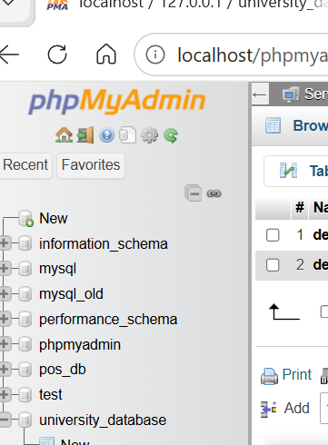
Step 2: Create Departments Table:
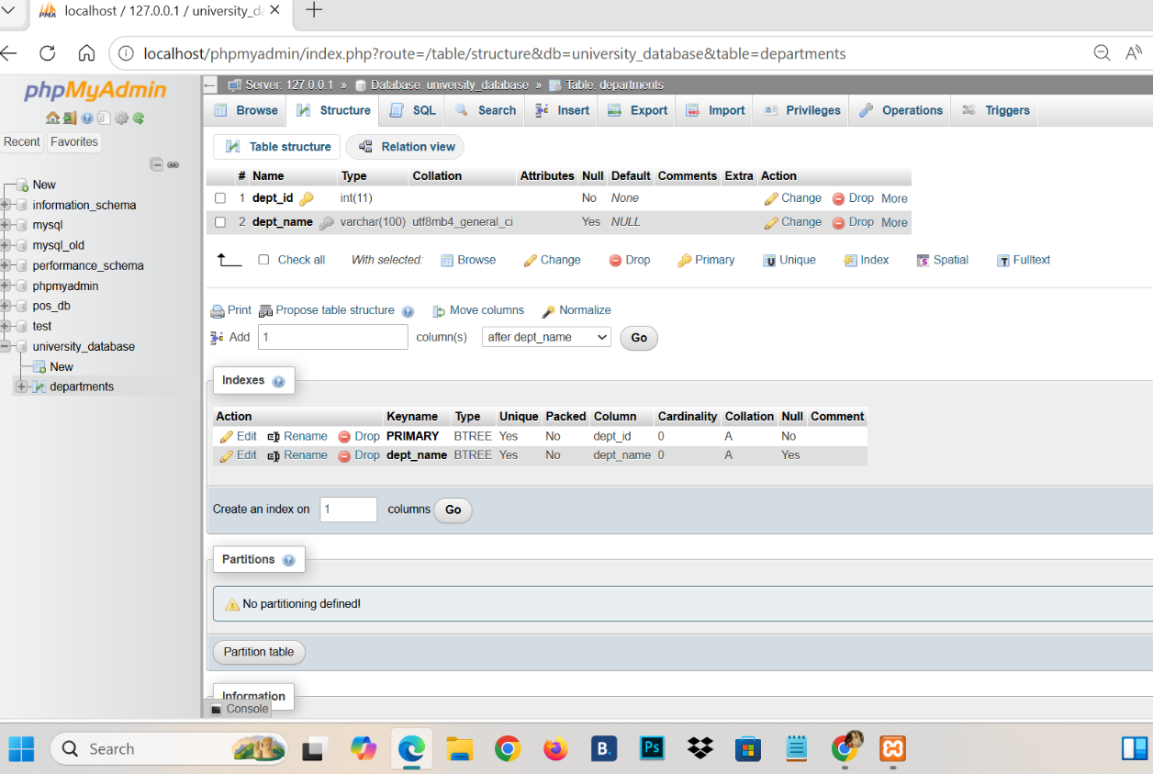
Step 3: Create Students Table:
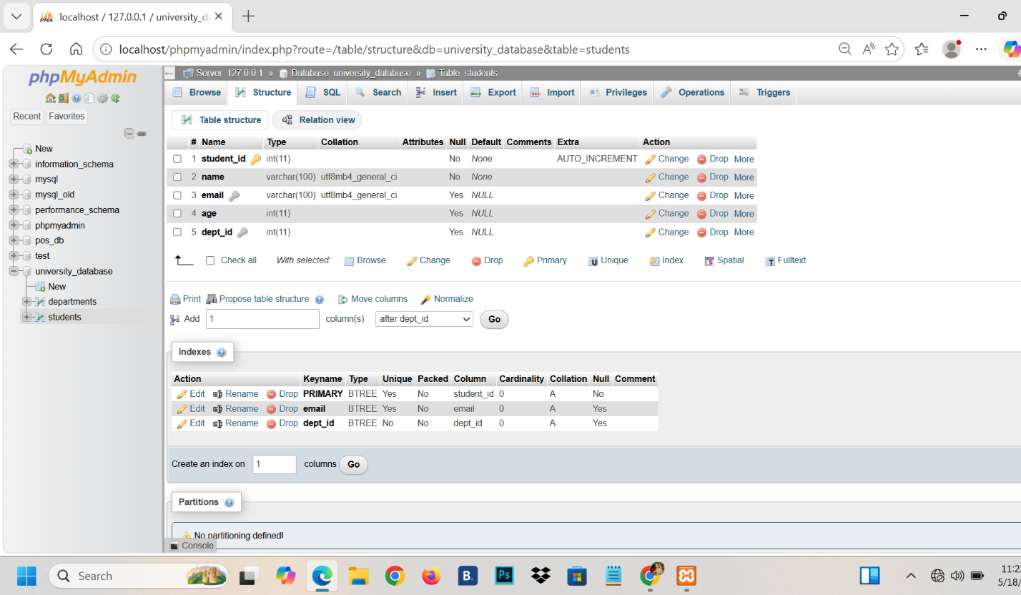
Step 4: Create Courses Table:
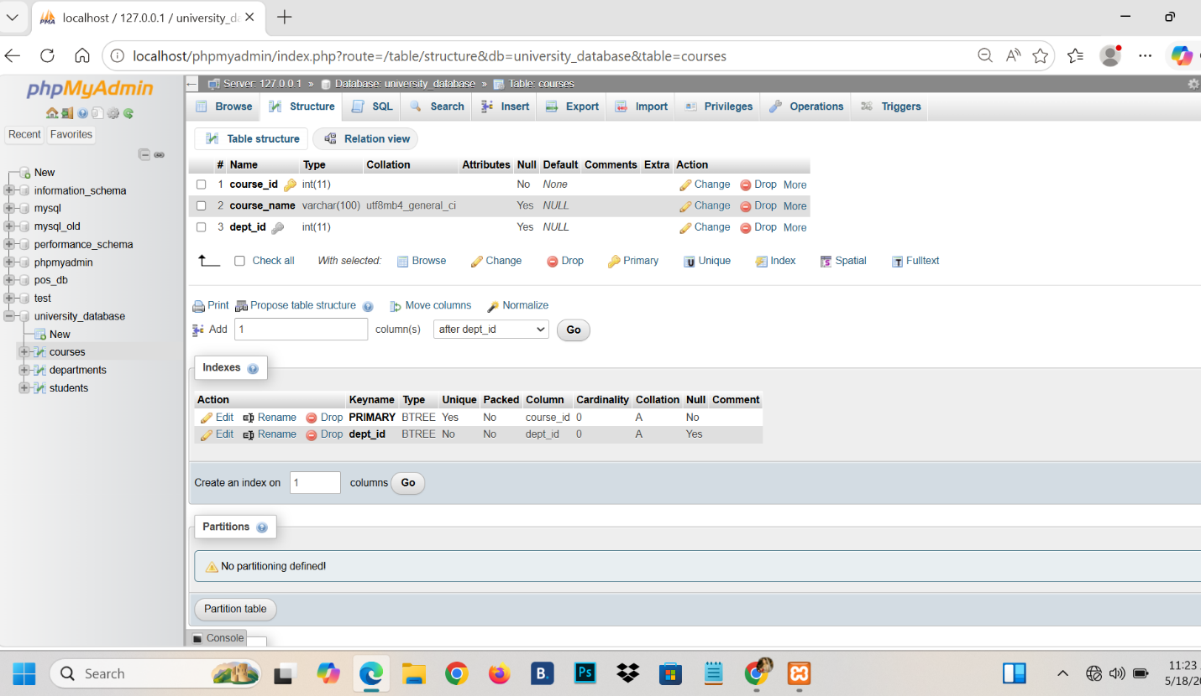
Step 5: Create Instructors Table:
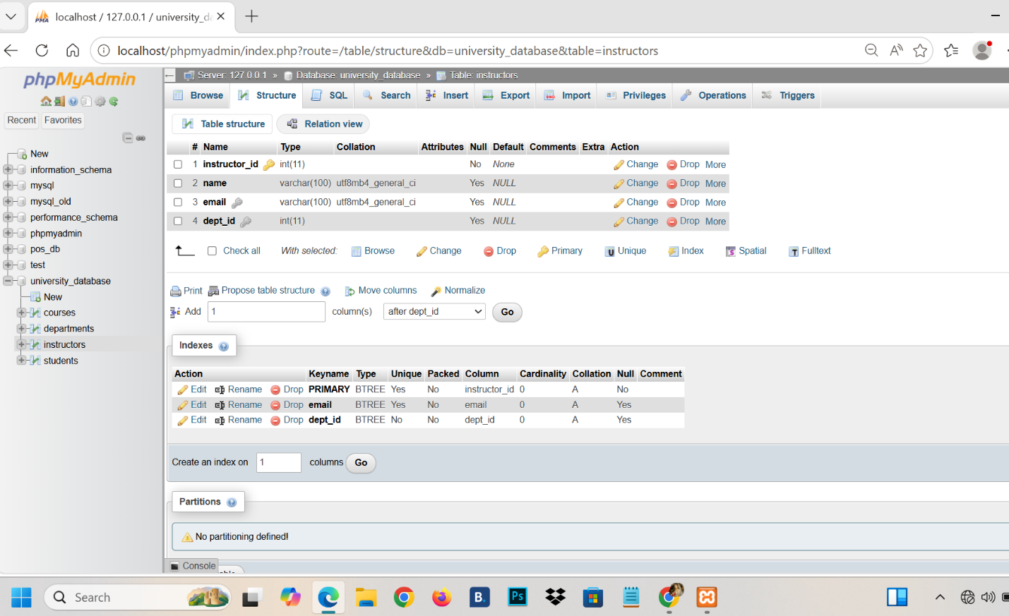
Step 6: Create Enrollments Table:
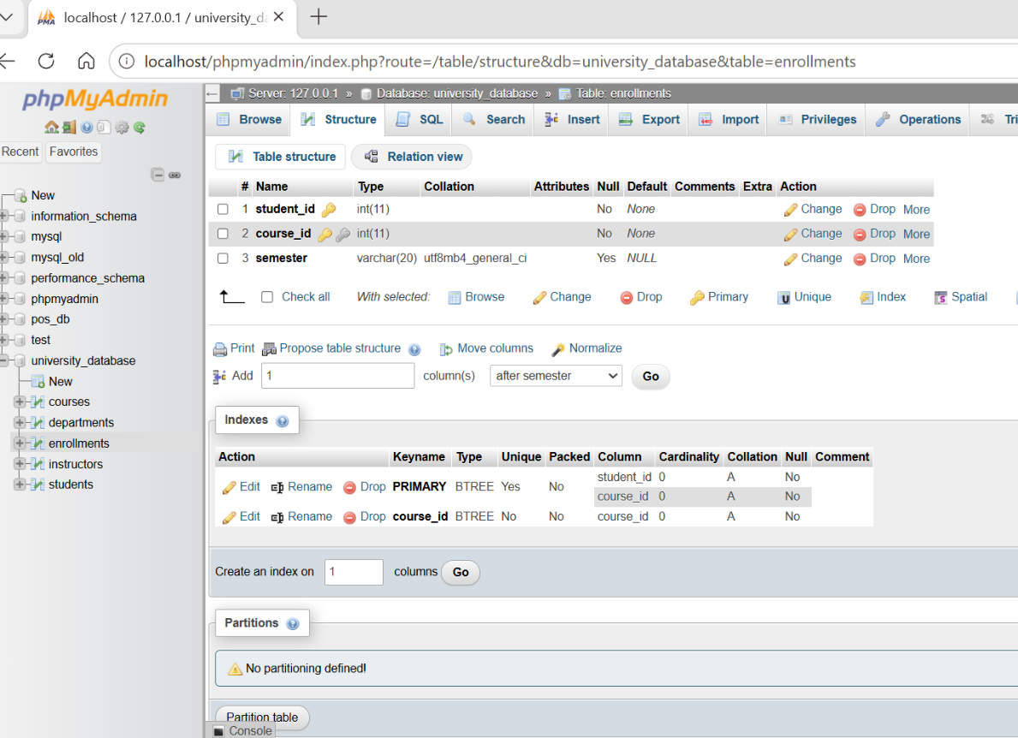
Step 7: Insert Data into Departments:
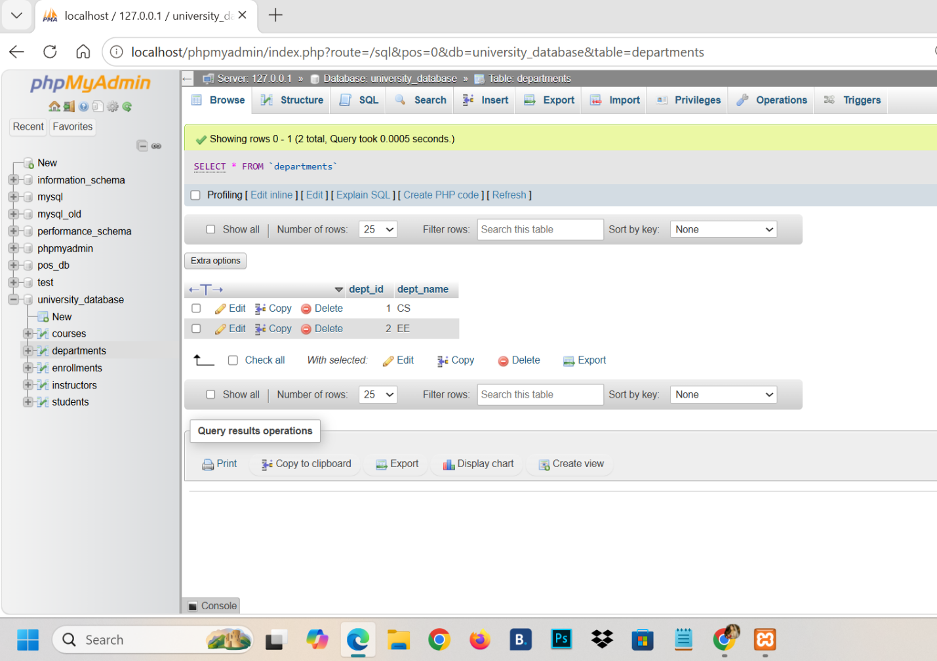
Step 8: Insert Data into Students:
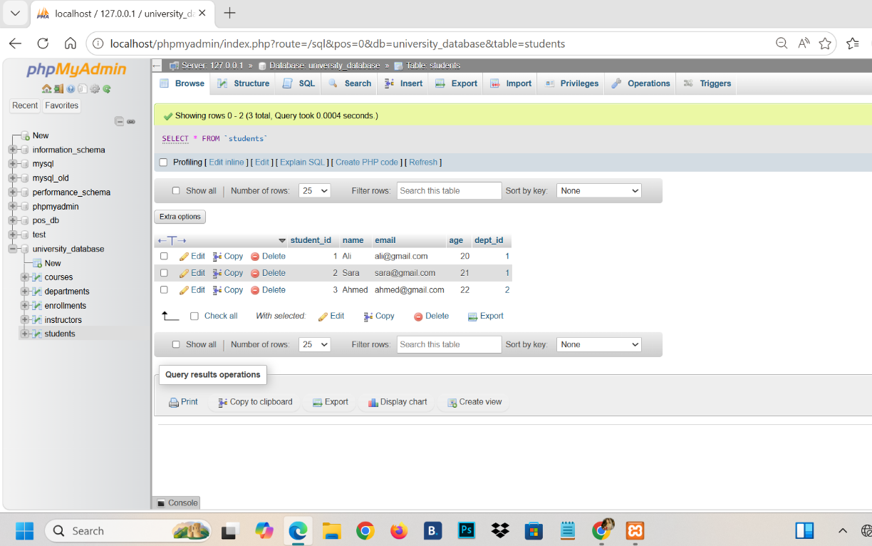
Step 9: Insert Data into Courses:
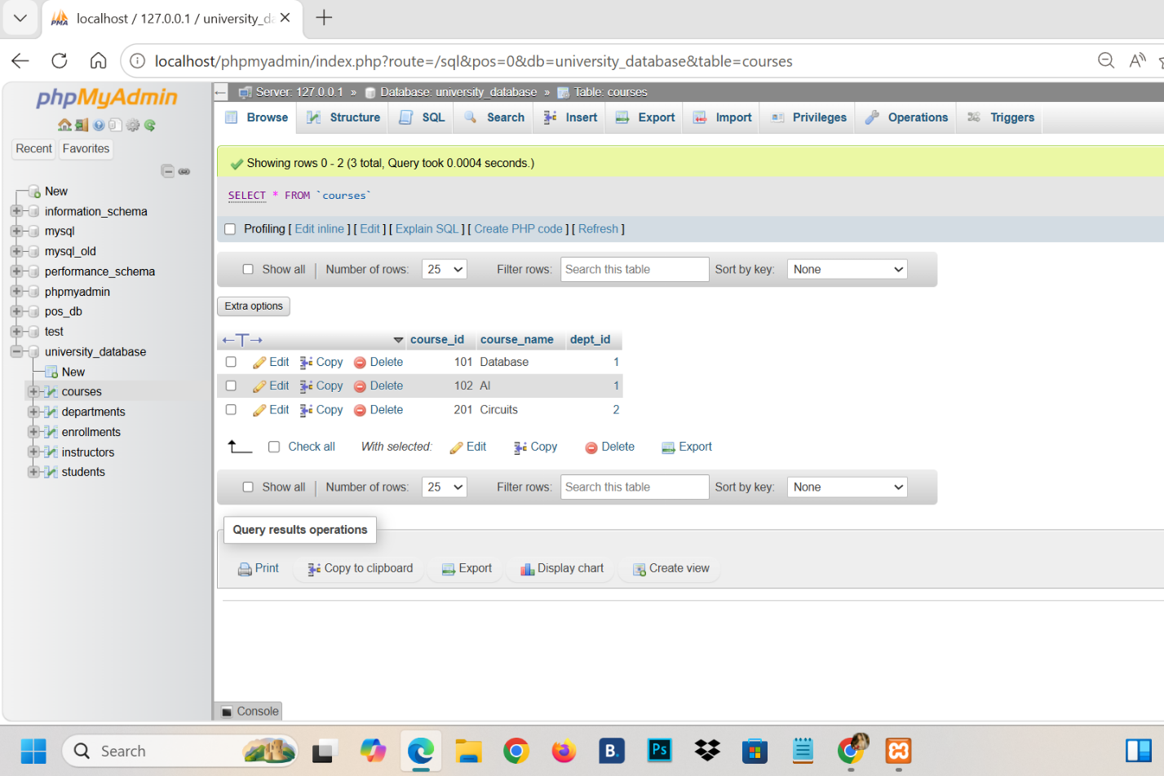

Step 10: Insert Data into Enrollments:
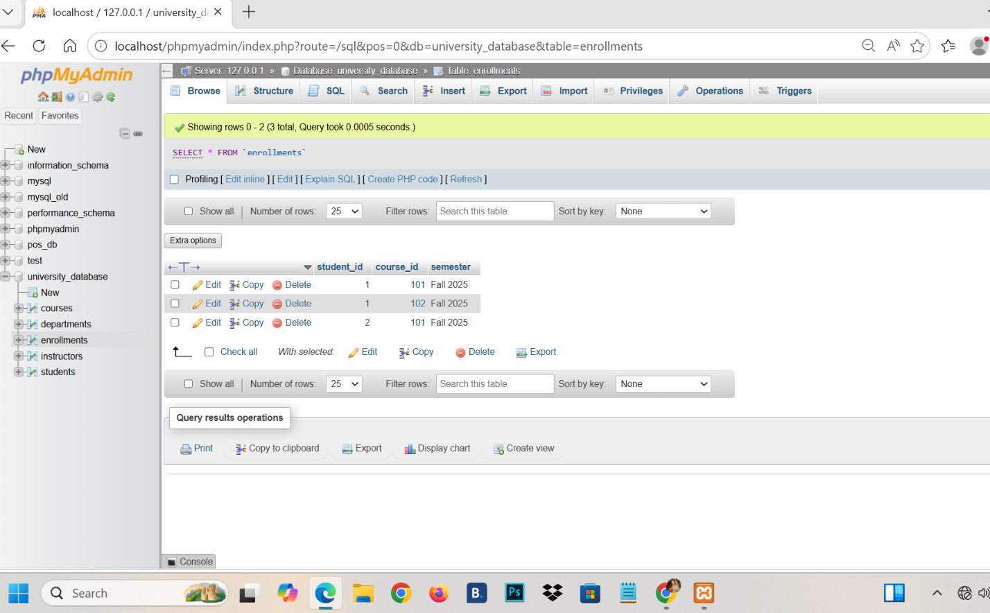

Step 11: Show Data using SELECT:
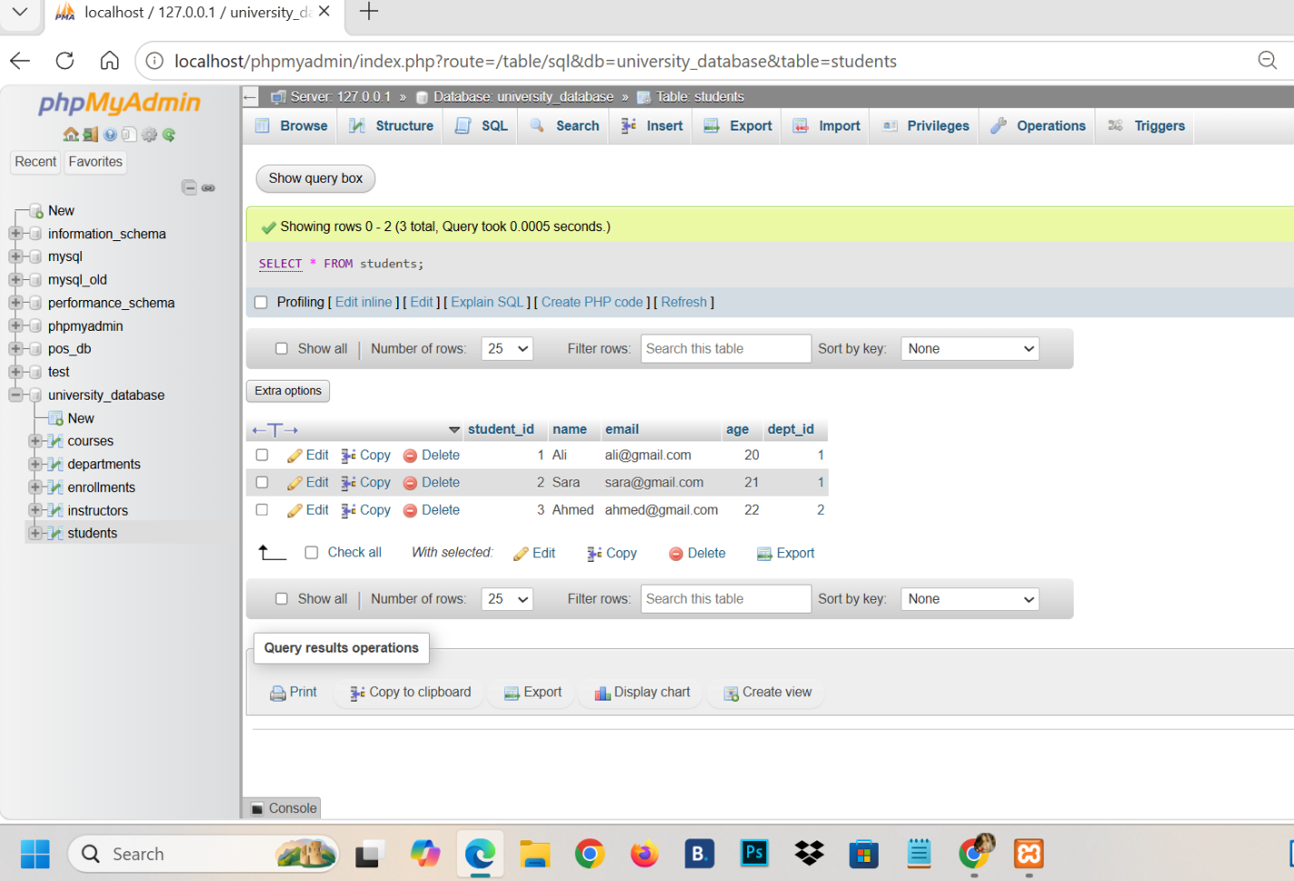
Step 12: Update Student Name:

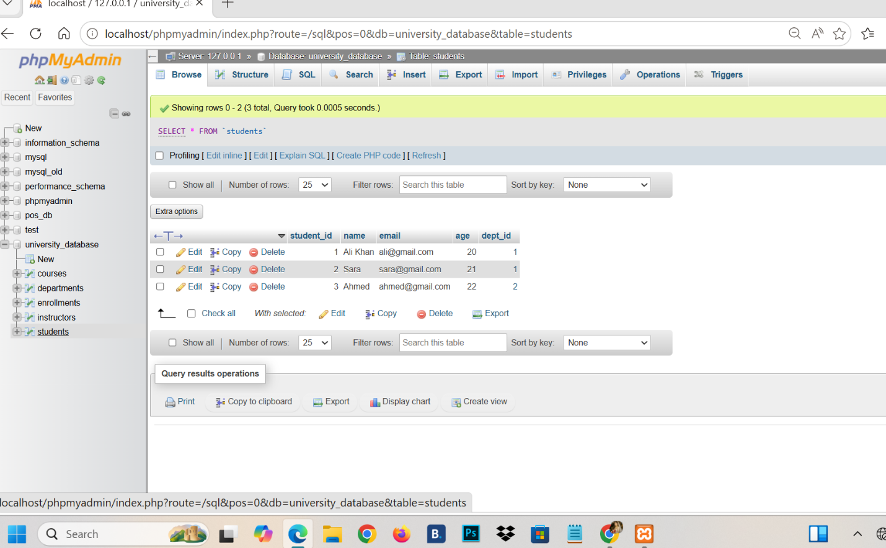

Step 13: Delete Student Record:

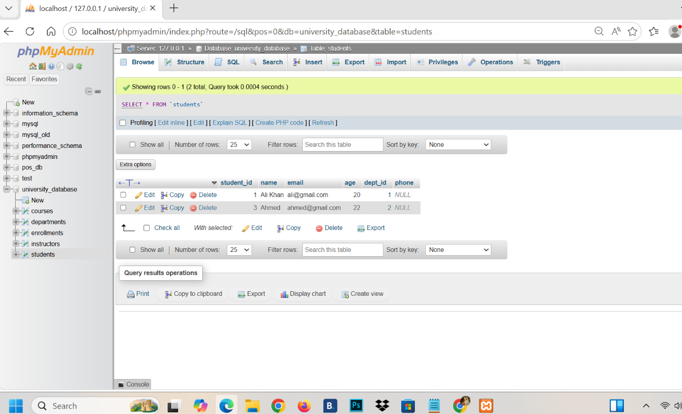
Step 14: Add New Column:
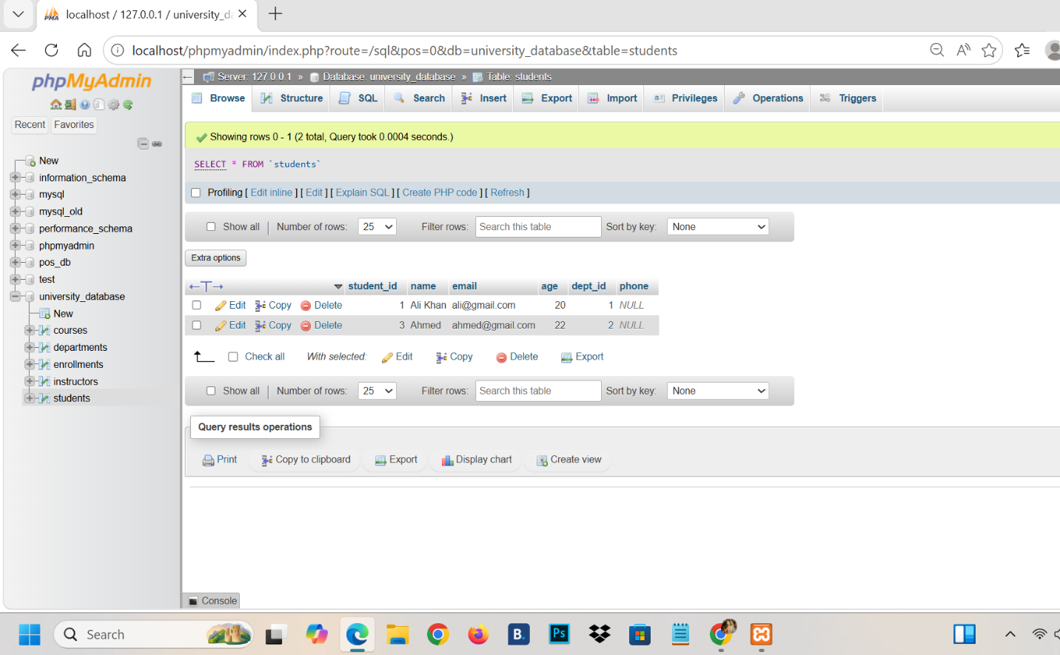

Step 15: Modify Column:

Step 16: Rename Column:

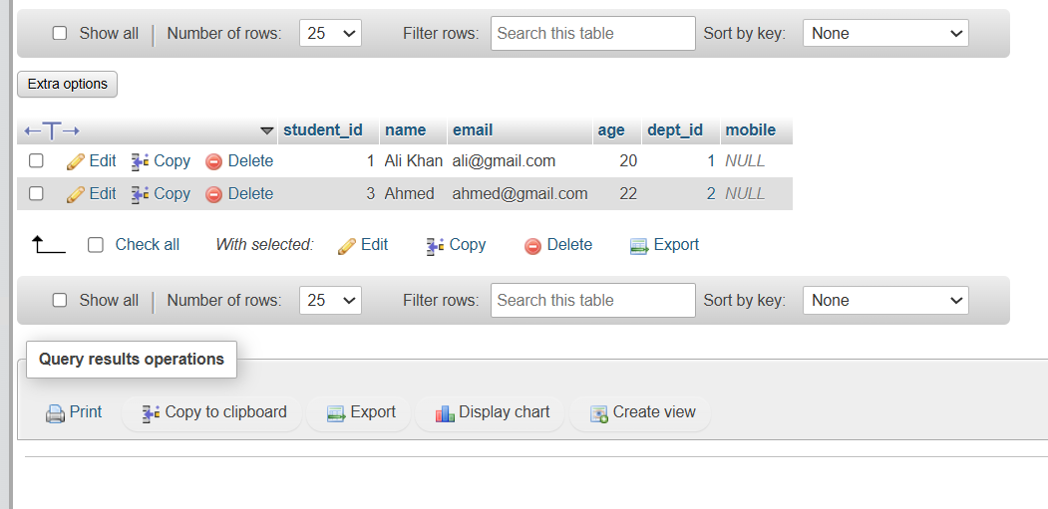

Step 17: Drop Column:
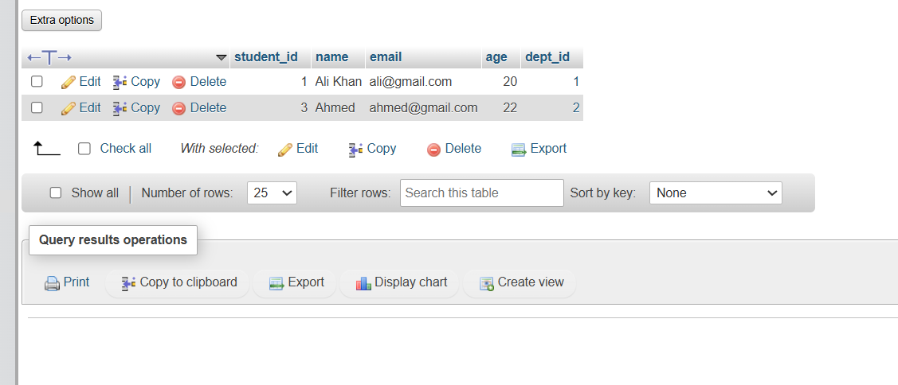
Step 18: Practice JOIN
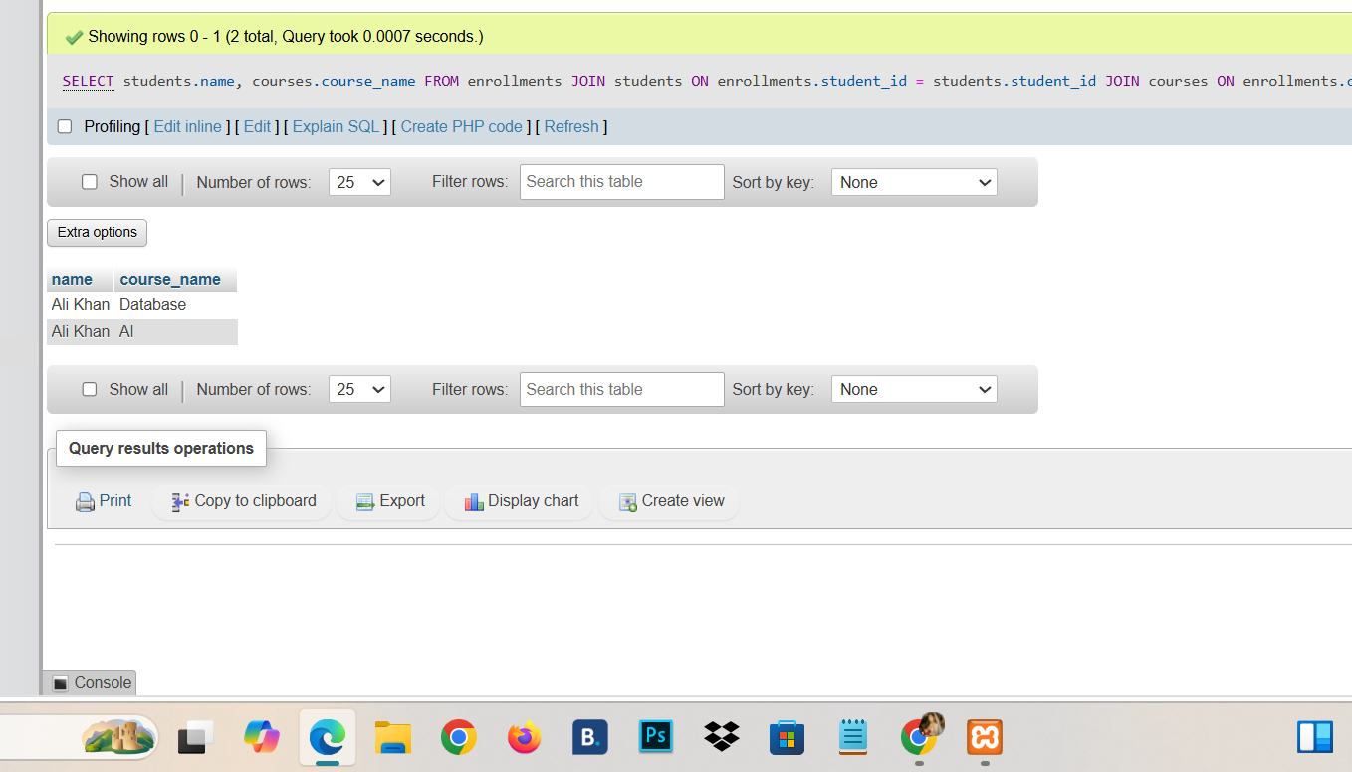
Step 19: TRUNCATE Table:
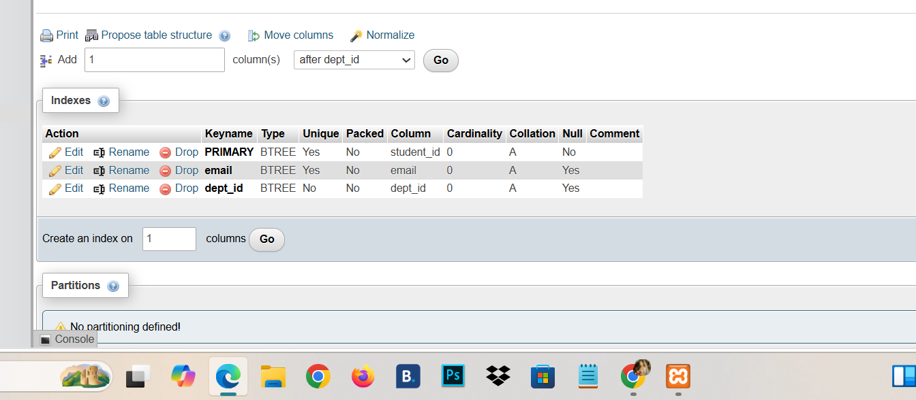

Step 20: DROP Table:
